**LAB: 04**

**SUPERVISED LEARNING (NAÏVE BAYES ALGORITHM)**

**OBJECTIVE**

Implementing supervised learning, Naïve Bayes algorithm for training, testing and classification.

**Lab Tasks:**

**Weather Temperature Play**

#### 

#### Fig 1

1. Implement Naïve Bayes Algorithm on the above dataset in Fig 1 to predict whether the players can play or not when the weather is overcast and the temperature is mild.

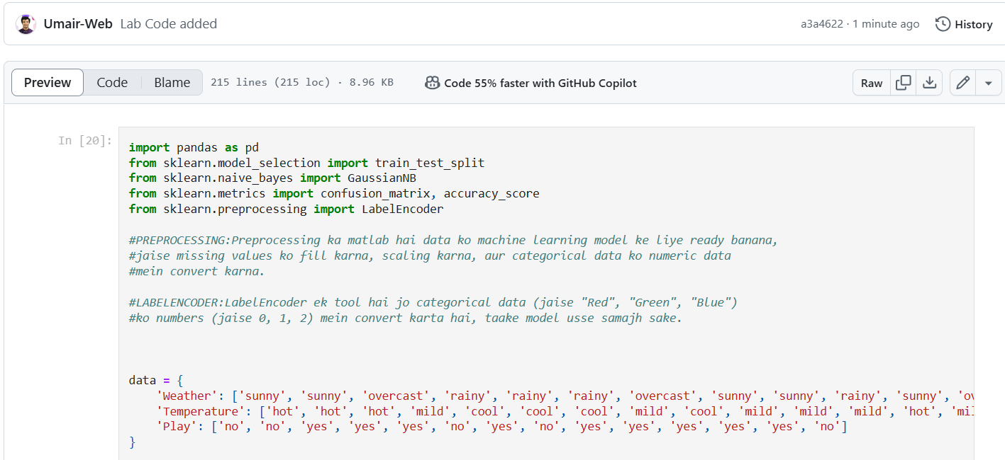

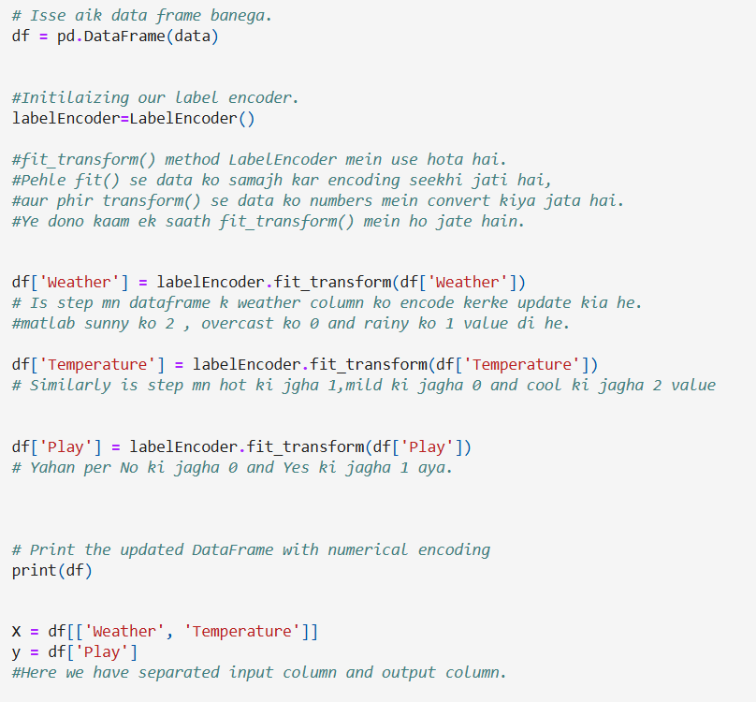

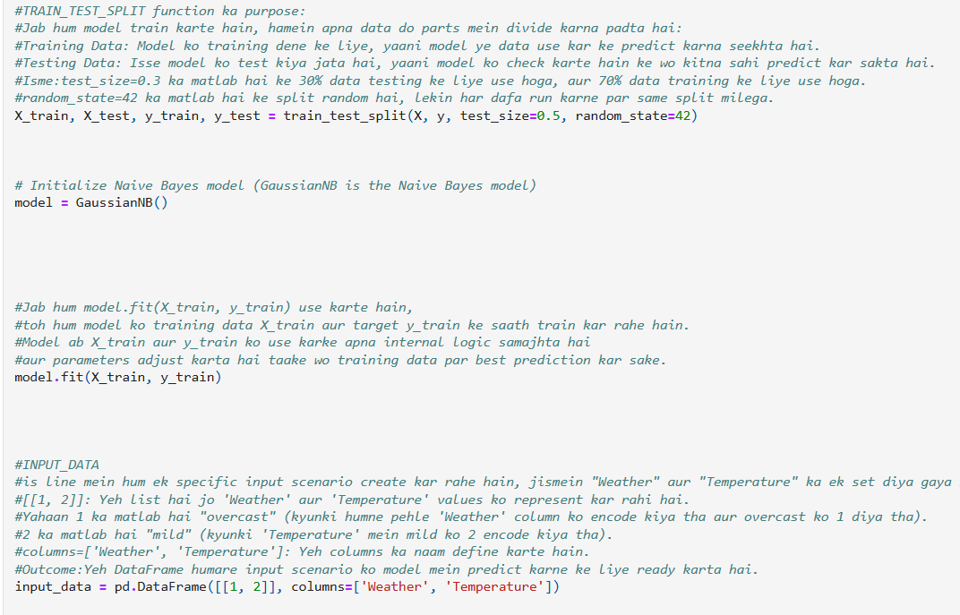

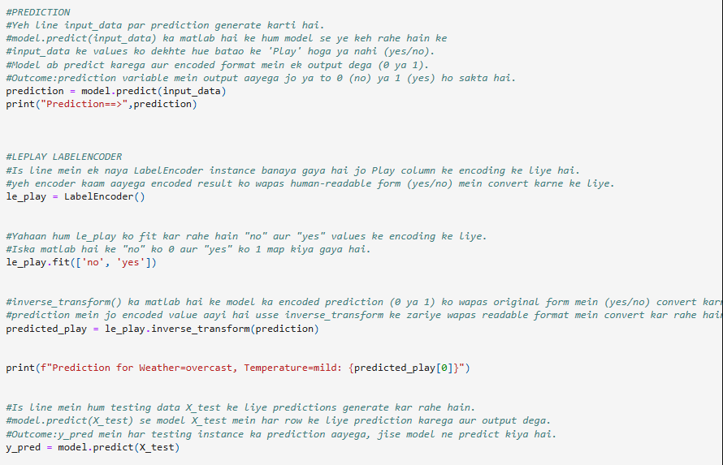

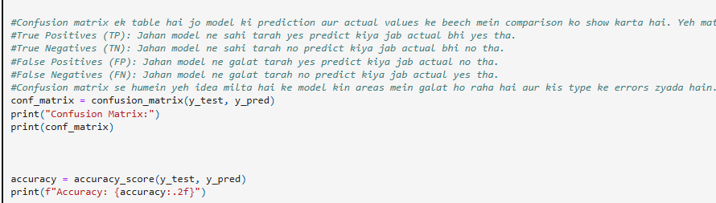

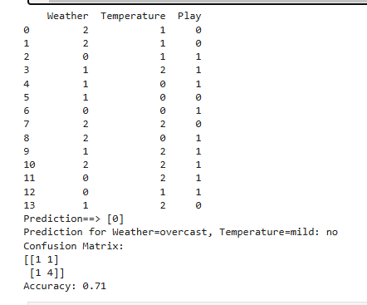

1. Consider the following dataset. Implement Naïve Bayes Algorithm to classify youth/medium/yes/fair**.**

